EECS E6893 HW3

Jing Qian (jq2282)

## Screenshot of code to do all the tasks.

### Top hashtags.

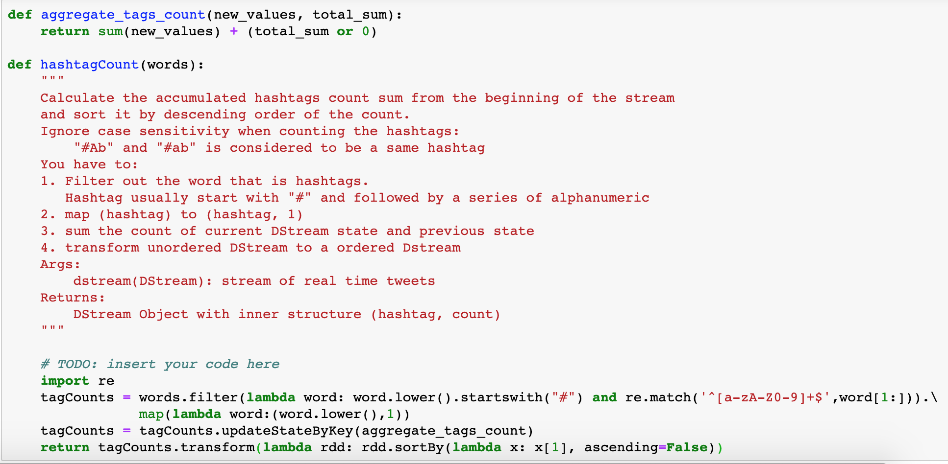

### Word counts.

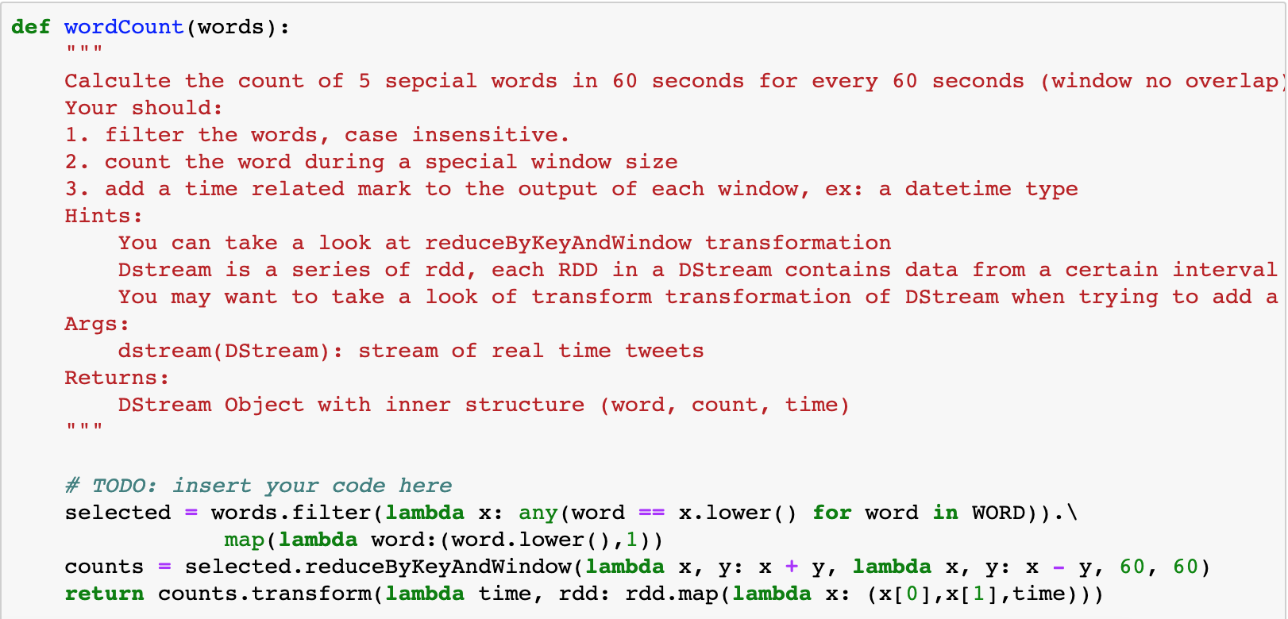

### Save to BigQuery.

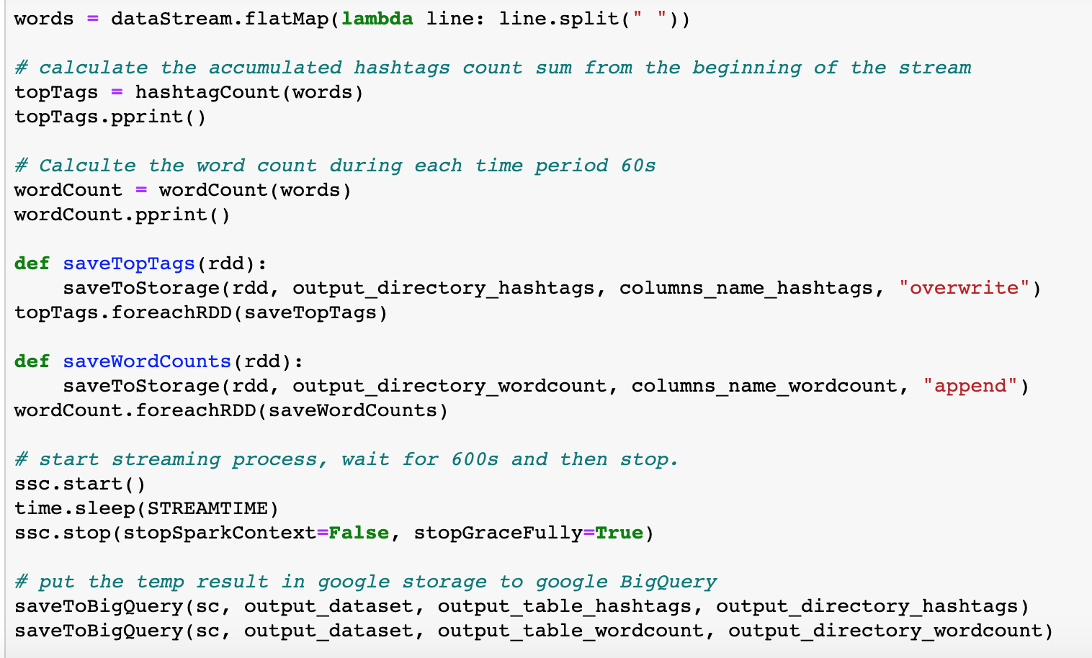

## b. Screenshot of the preview of data stored in BigQuery.

### Table of “hashtags”:

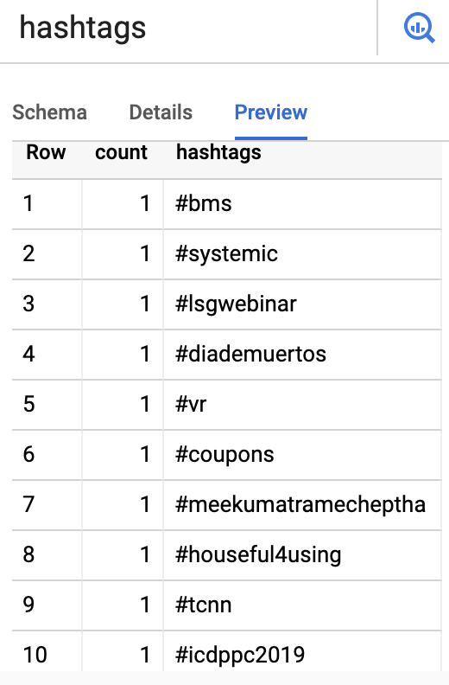

The hashtags are ordered descendingly in the pprint():

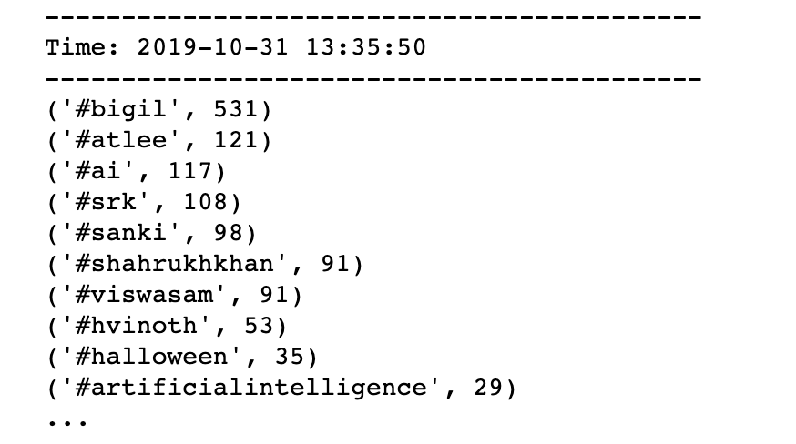

### Table of “wordcount”

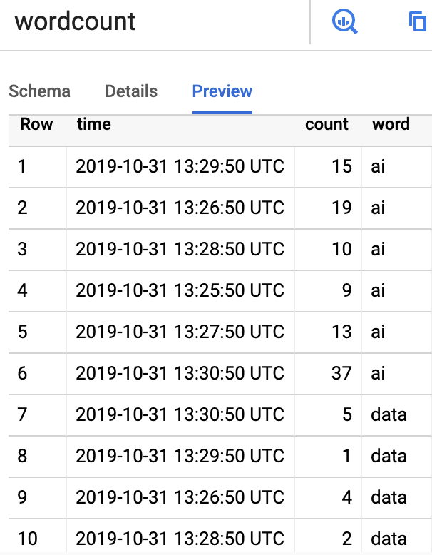

The output in the terminal is:

